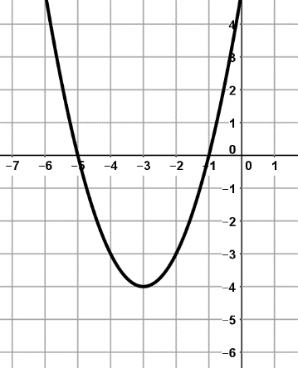
Write the Domain and Range in set notation and interval notation.
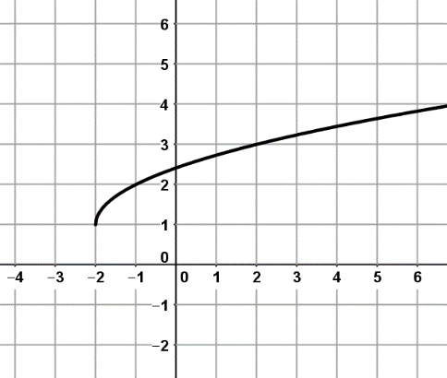
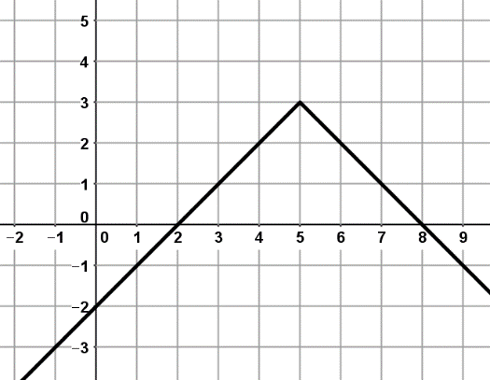
1) 2) 3)

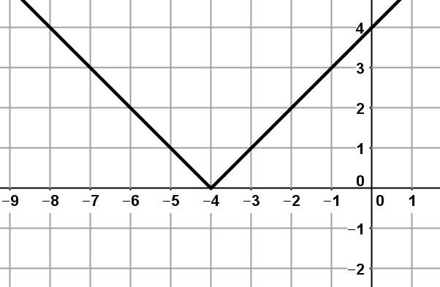
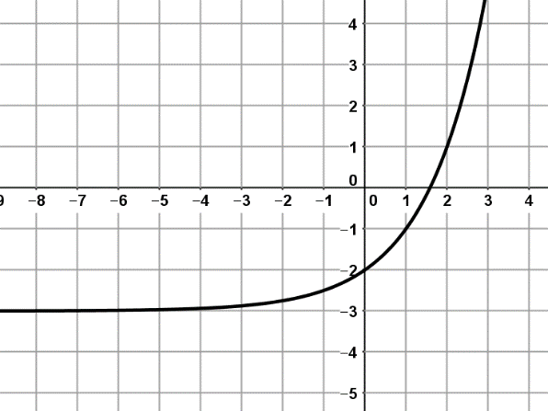
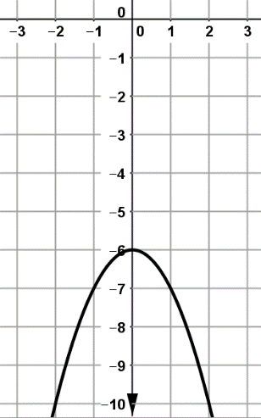
4) 5) 6)

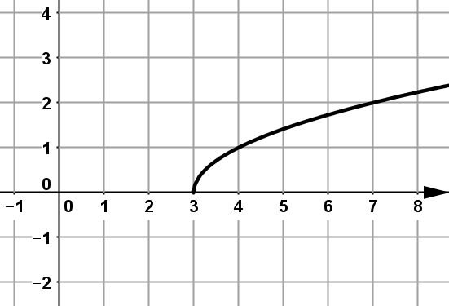
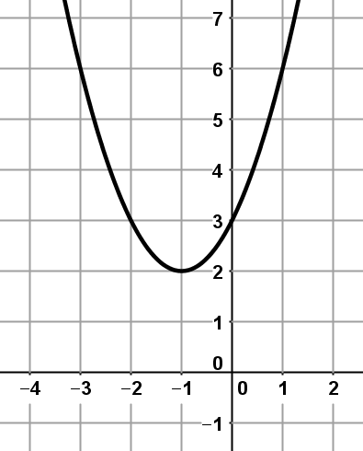
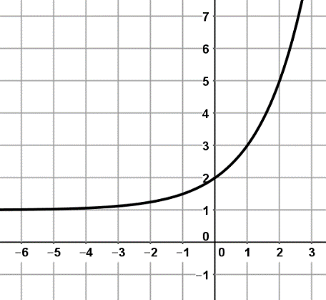
7) 8) 9)

ANSWERS
- Set notation
Domain: $\left\{-∞<x<+∞\right\}$
Range: $\left\{y≥-3\right\}$
Interval Notation
Domain: $(-∞. +∞)$
Range: [-3, $∞$)

- Set notation
Domain: $\left\{-∞<x<+∞\right\}$
Range: {$y≤3\}$
Interval Notation
Domain: $(-∞, +∞)$
Range: ($-∞, 3)$

- Set notation
Domain: $\{x≥-2\}$
Range: $\{y≥1\}$
Interval Notation
Domain: [-2, $∞)$
Range: [1, $∞)$

- Set notation
Domain: $\left\{-∞<x<+∞\right\}$
Range: {$y≤-6\}$
Interval Notation
Domain: $(-∞. +∞)$
Range: $(-∞, -6]$

- Set notation
Domain: $\left\{-∞<x<+∞\right\}$
Range: {$y>-3\}$
Interval Notation
Domain: $(-∞. +∞)$
Range: (-3, +$∞)$

- Set notation
Domain: $\left\{-∞<x<+∞\right\}$
Range: {$y≥0$}
Interval Notation
Domain: $(-∞. +∞)$
Range: [0, $+∞$)

- Set notation
Domain: {$x≥3\}$
Range: {$y≥1\}$
Interval Notation
Domain: [3,$+∞)$
Range: [0, $+∞)$

- Set notation
Domain: $\left\{-∞<x<+∞\right\}$
Range: { $y>1\}$
Interval Notation
Domain: $(-∞. +∞)$
Range: (1, $+∞)$

- Set notation
Domain: $\left\{-∞<x<+∞\right\}$
Range: {$y≥2\}$
Interval Notation
Domain: $(-∞. +∞)$
Range: [2, +$∞)$

