Lesson 6.5 Comparing Linear Functions
1) Joe’s Plumbing and Mark’s Plumbing have different ways of charging their customers. The function $J\left(t\right)$ represents the total amount in dollars the Joe’s Plumbing charges for $t$ hours of work. Mark’s Plumbing Service charges $45 per hour plus a $25 trip charge.
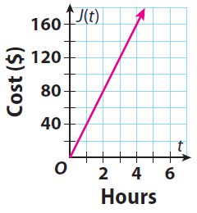
a) Which plumbing service has the large y-intercept?

b) Which plumbing service have the smaller rate per hours?

c) What is the difference between the smallest range value for the two plumbing services.

2) Sam $S(x)$ and Andrea $A(x)$ are both taking a trip. The tables below represent that traveling distance per day. If $x$ represents days and $S\left(x\right) and A(x)$ represents miles traveled.
$$x$$ | $$S(x)$$
1 | 120
2 | 150
3 | 110
4 | 160
$$x$$ | $$A(x)$$
1 | 150
2 | 130
3 | 145
4 | 180

a) Who has the faster average rate of change?
b) Who traveled the farthest?

3) Given the function $f\left(x\right)= 4x+13$ and $g\left(x\right)$ in the table below.
$$x$$ | $$g(x)$$
1 | 17
2 | 22
3 | 27
4 | 32

a) Which function has the slower rate of change?
b) Which function has a smaller y-intercept?
4) A rainstorm in Atlanta lasted for 2.5 hours, during which time it rained at a steady rate of 0.5 inch per hour. The function $A(t)$ represents the amount of rain that fell in $t$ hours. The graph below show the amount of rain that fell during a rainstorm in Knoxville, $K\left(t\right)$ (in inches) as a function of time $t$ (in hours).
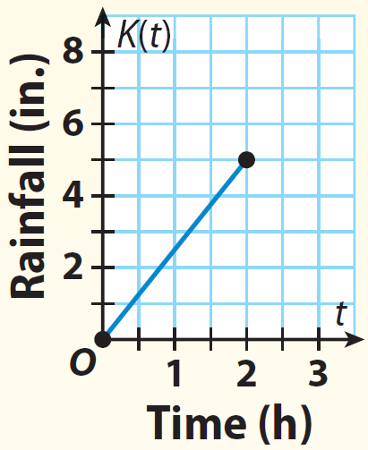
a) Which city had the larger domain?

b) Which city has the fastest rain fall?

c) Which city has the smallest y-intercept?

5) Robot Kevin,$K(t)$, and Robot Andrew, $A(t)$, are running in a race.
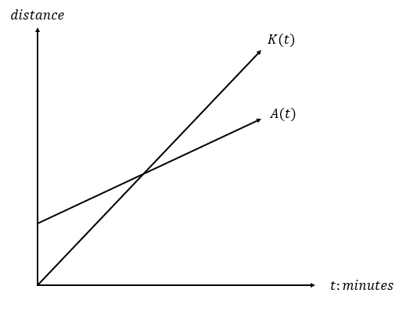

a) When the two lines intersect what does that point mean in context of the story?
b) Who is running faster before they meet up in the race? Back up your answer with calculations.
c) If $A(t)$ has a y-intercept of $(0,5)$, what does the y-intercept mean in the context of the story?
d) What is the domain for Robot Kevin and Robot Andrew?
e) What is the range for Robot Kevin and Robot Andrew? Who have the smaller range?

6) The linear functions $f(x)$ and $g(x)$ are defined by the graph and the table below. Assume the domain for $g\left(x\right)$ is restricted to the value in the table.
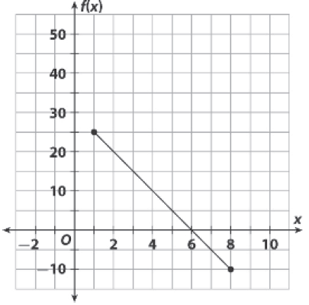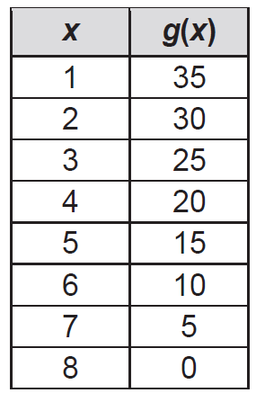
a) Which function has the smaller x-intercept?
b) If $g(x)$ had no domain restriction, which function would have the smaller y-intercept?
c) Compare the two functions, which function has a larger value for when the input in 4?

7) Jesse and Nick are 375 meters apart. Jesse runs towards Nick at 6 meters per second. Nick runs towards Jesse at 9 meters per second. If $x$ represents seconds and $y$ represents meters, Jesse’s equation is $J(x)=6x$ and Nick’s equation is $N(x)=375-9x$. After how many seconds will they meet up with each other?

8) Compare the two function $3x+4y=12$ and $f\left(x\right)=-\frac{3}{2}x+4$.
a) Which function has the smaller y-intercept?
b) Which function has the smaller x-intercept?
c) Which function decreases the quickest?

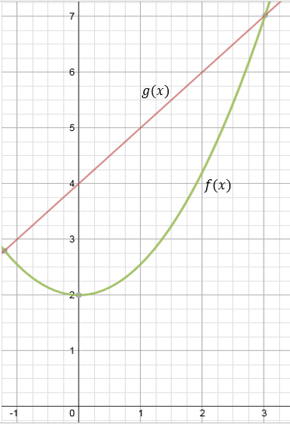
9) Given function $f(x)$ and $g(x)$ in the graph above.
a) What are the average rate of change given the domain for both functions to be $0≤x≤3$?
b) Which function has the fastest average rate of change?

10) Compare $f(x)$ and $g\left(x\right)$ below.
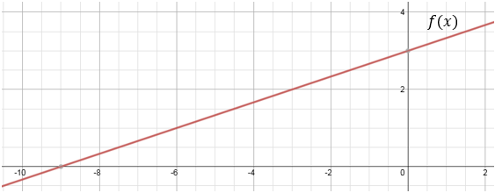
$$x$$ | -16 | -12 | -8 | -4 | 0 | 4 | 8 | 12 | 16
$$g(x)$$ | -3 | -2 | -1 | 0 | 1 | 2 | 3 | 4 | 5

a) Which function has the faster rate of change?
b) Which function has the smaller y-intercept?
c) Which function has the smaller x-intercept?

